**Kitepower to develop test site on La Gomera in collaboration with CT Ingenieros and the support of the Island government**

**Kitepower, a leading Airborne Wind Energy company specializing in kites for power generation, announces its partnership with CT Ingenieros for the development of an Airborne Wind Energy (AWE) test site on La Gomera, one of the Canary Islands.**

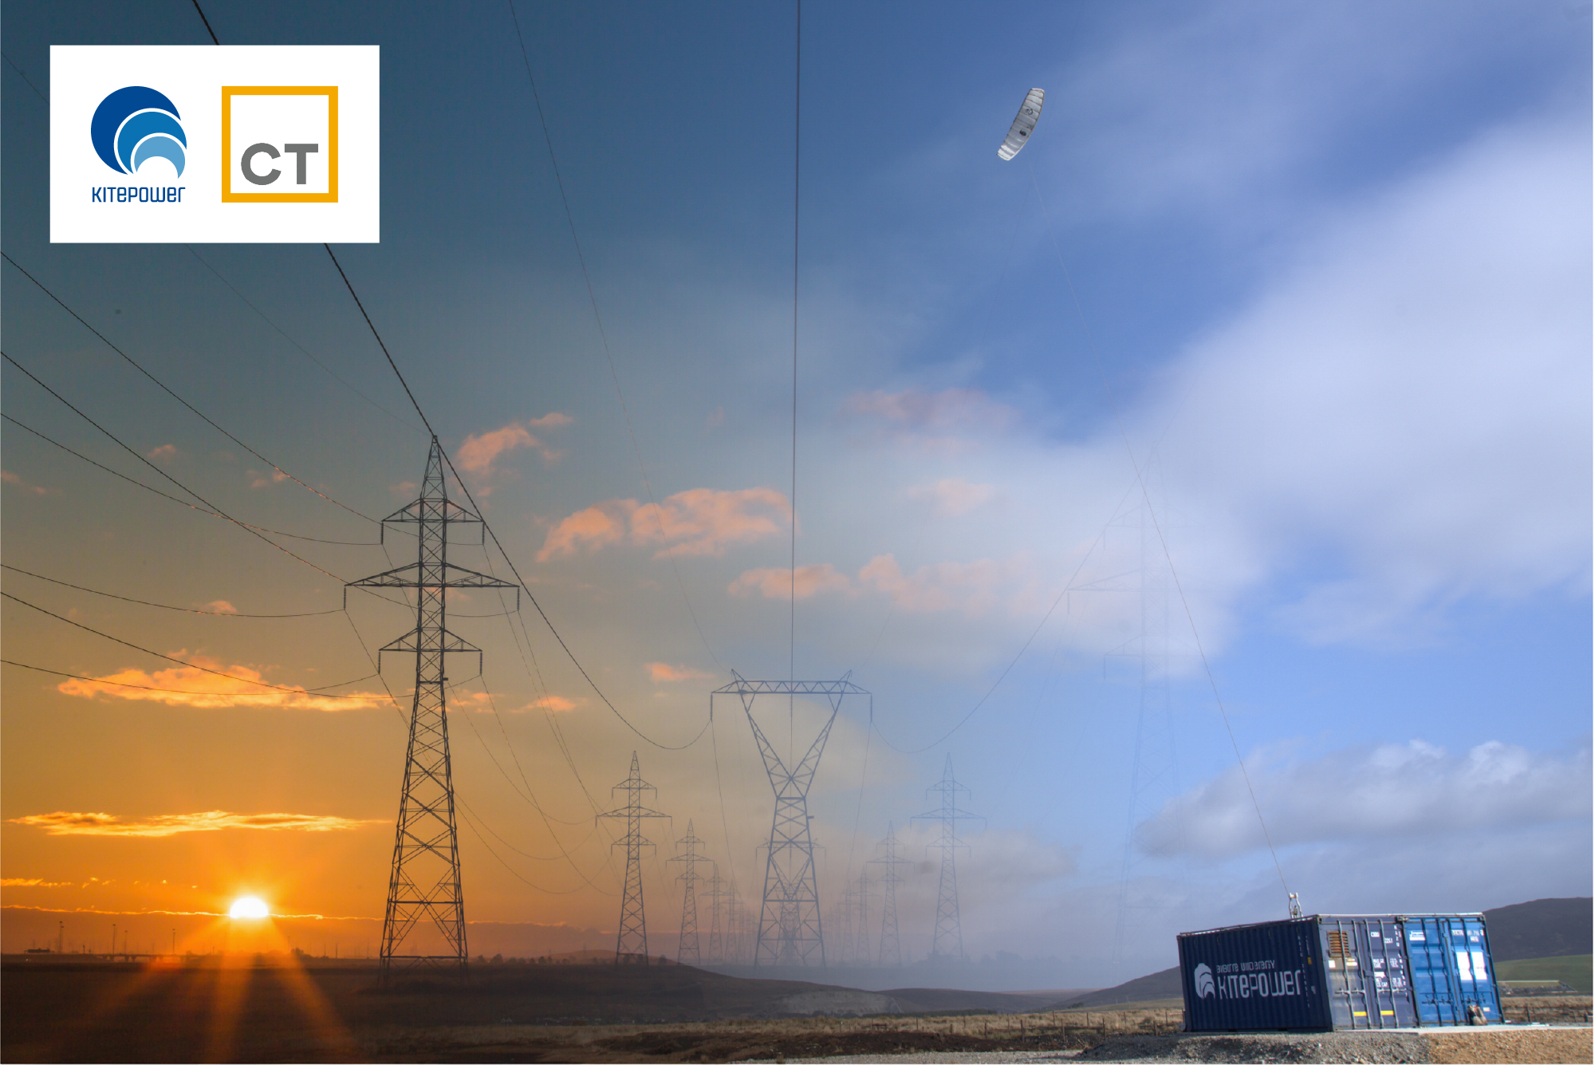

This announcement follows discussions aimed at demonstrating a Kitepower system and assessing the feasibility of La Gomera Island as an Airborne Wind Energy Center of Excellence. CT Ingenieros, Kitepower’s primary partner in the project, with the support of the Island Government, is planning to construct a Flight Test Center on the island, with Kitepower as the first occupants.

**Three phases**

The project, scheduled to commence in the fourth quarter of 2024, will consist of three phases. The initial phase will involve a three-month demonstration and feasibility study with our system onsite to showcase the capabilities of the FTC. The second phase will focus on power production for a duration of one to two years, followed by continuous operation in the third phase spanning four to six years.

**Airborne wind energy innovation**

"This collaboration represents a significant milestone for both Kitepower and the entire Airborne Wind Energy industry," stated Johannes Peschel, CEO of Kitepower. "We are excited to demonstrate our systems and explore the potential of La Gomera as a hub for airborne wind energy innovation. This project will not only advance our technological capabilities but also contribute to the economic, social, and environmental objectives of La Gomera."

“CT is proud to be a part of this groundbreaking project," said Agustin Arjonilla, Senior Consultant at CT. “We believe that Airborne Wind Energy has the potential to revolutionize the way we generate clean energy, and we are confident that this testing site will play a key role in advancing this technology in this particular area."

The partnership between Kitepower and CT underscores the importance of public-private collaborations in fostering innovation and sustainable development. La Gomera sees this project as an opportunity to diversify its economy and emerge as a leading center for energy generation and technological advancement.

A few weeks ago, Kristian Petrick, Secretary General of the sector association Airborne Wind Europe signed a Memorandum of Understanding with the Cabildo of La Gomera: “We are very grateful for the opportunity that La Gomera offers to the AWE sector. With CT Ingenieros and Kitepower leading the project, we are confident that we will see the first kites flying on La Gomera already by the end of this year, demonstrating how fast this technology can be implemented.”

**About CT**

CT is a leading engineering company throughout the complete product lifecycle. For more than 35 years, our mission has been to provide innovative services and technological solutions that help our clients be more effective and competitive. Today, CT´s success is driven by 2.000+ engineers in seven countries providing end-to-end expert support to leading customers in the aeronautical, space, naval, automotive, railway, energy and industrial plant sectors.

[www.thectengineeringgroup.com](http://www.thectengineeringgroup.com)

**About Airborne Wind Europe**

Airborne Wind Europe is the association of the Airborne Wind Energy (AWE) sector. It promotes the development and deployment of AWE Systems, i.e. tethered kites that generate energy from high-altitude wind. Airborne Wind Europe encourages collaboration and exchange between technology developers, policy makers, research institutes and universities, as well as other stakeholders like public administration and authorities, suppliers, utilities, energy consumers, investors and financial institutions.

[www.airbornewindeurope.org](http://www.airbornewindeurope.org)

**Over: Kitepower**

Kitepower, a leading start-up in Airborne Wind Energy (AWE), develops innovative and cost-effective alternatives to traditional wind turbines. Using up to 90% less material, Kitepower&#039;s patented technology is potentially twice as efficient. Unlike conventional turbines, Kitepower systems require no towers or heavy foundations, making them highly mobile and easy to install. They harness stronger, persistent winds at higher altitudes, achieving capacity factors over 0.5 for cost-effective electricity generation. Founded in 2016 by Johannes Peschel and Roland Schmehl as a spin-out from Delft University of Technology, Kitepower collaborates with the Dutch Ministry of Defence, the UN World Food Program, and RWE Renewables.

**Newsroom**

Bekijk het volledige persbericht inclusief meer foto's en video's in onze Newsroom.

[Bekijk het volledige persbericht](https://kitepower.presscloud.ai/pers/kitepower-to-develop-test-site-on-la-gomera-in-collaboration-with-ct-ingenieros-and-the-support-of-the-island-government)

[Bekijk alle voorgaande persberichten](https://kitepower.presscloud.ai)

**Contact informatie**

E-mail: v.vanparijs@kitepower.nl