**Kitepower launches rental-first strategy to meet rising demand for sustainable energy solutions**

**Kitepower, a pioneer in airborne wind energy systems, today announced the launch of a new rental-first model for a select group of early customers. This initiative responds to the rising demand for flexible, cost-effective clean energy solutions across Europe.**

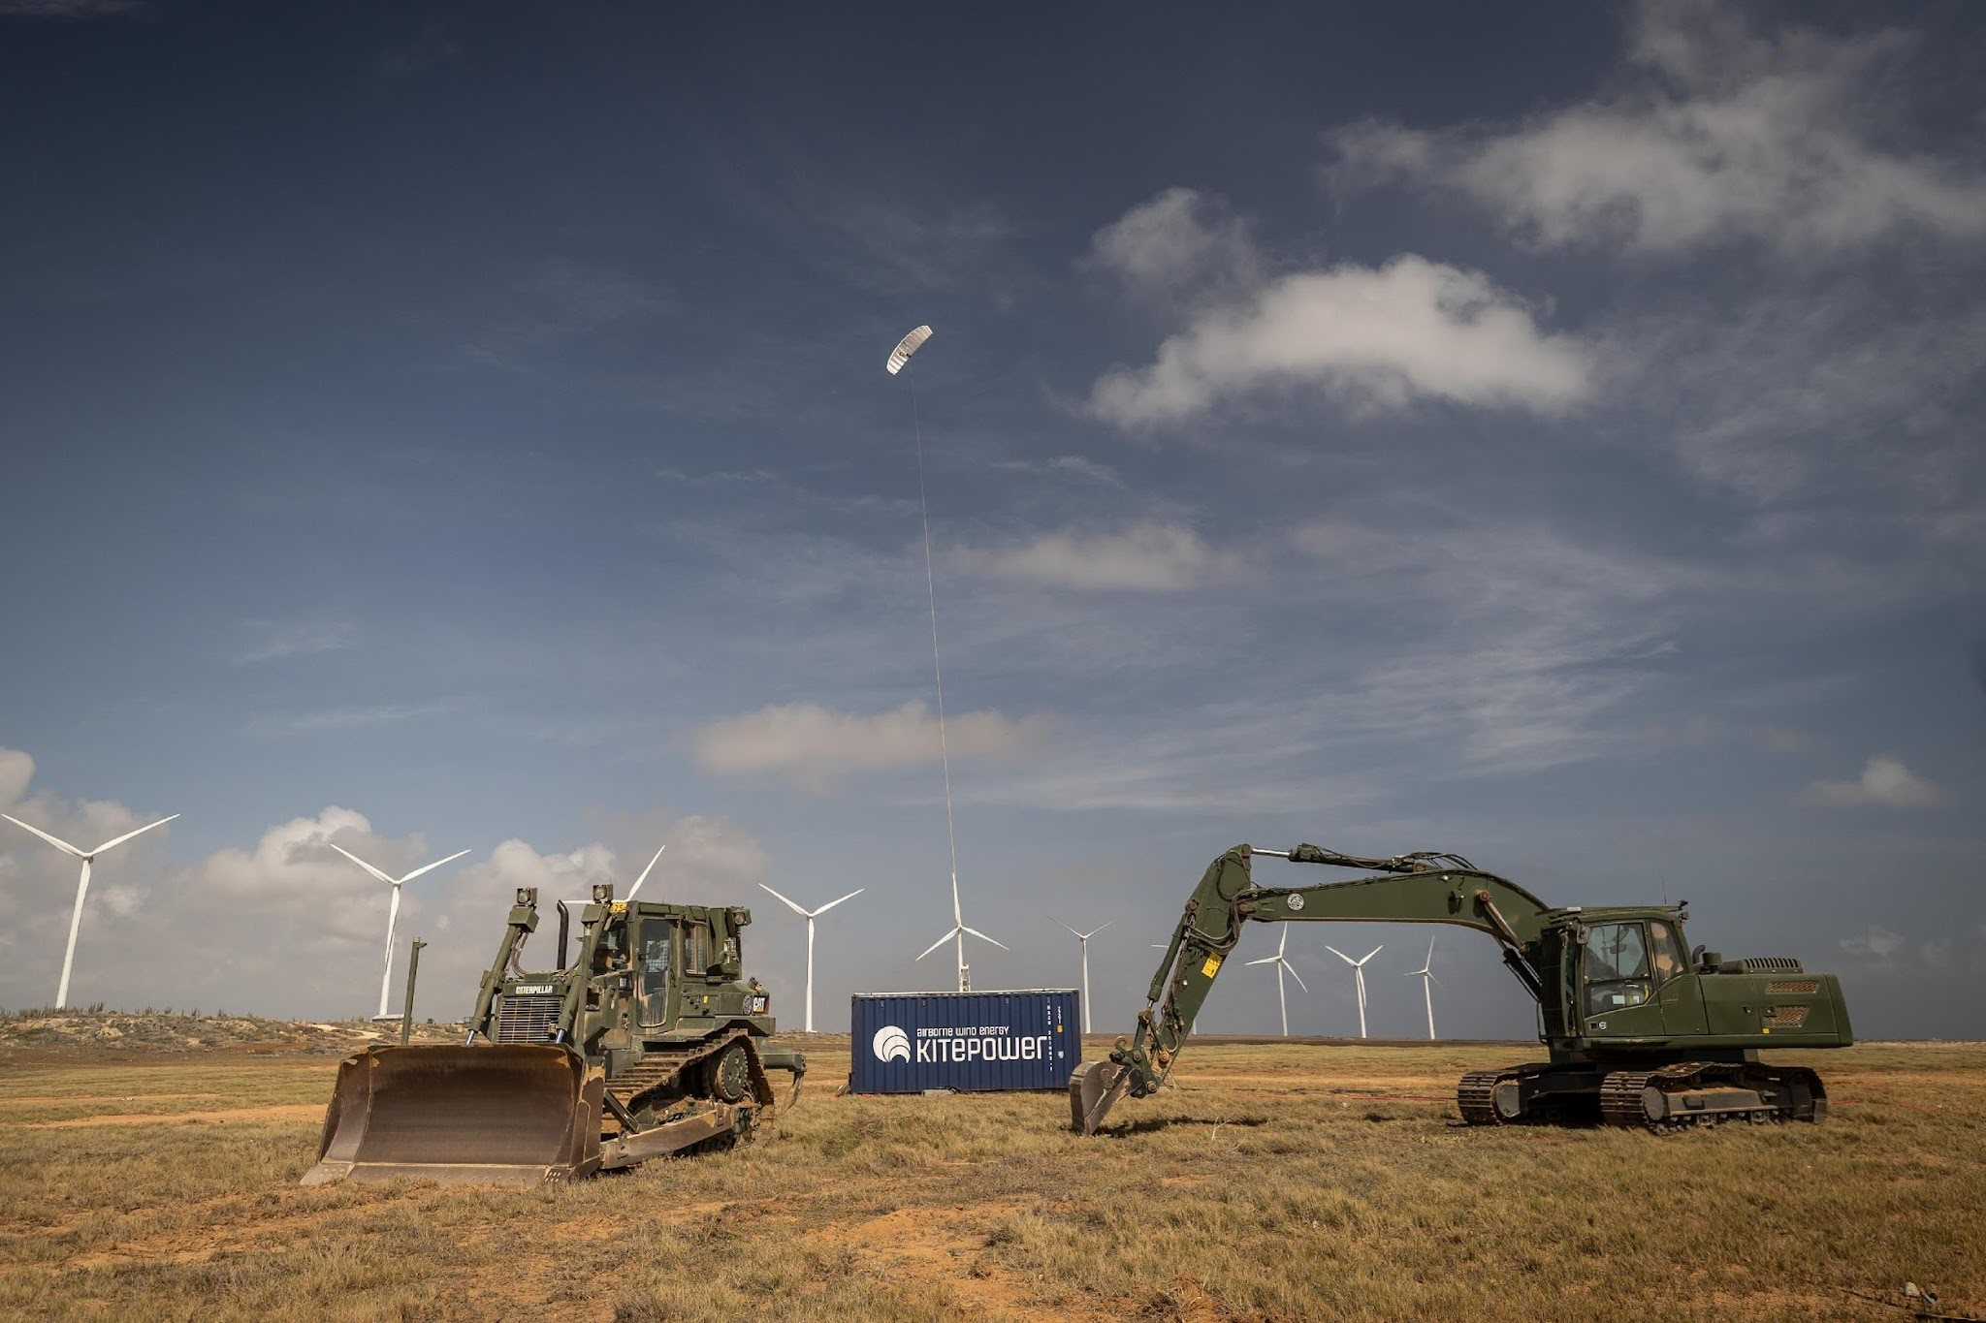

**Bridging the gap in renewable energy generation**

As the world moves towards a carbon-free future, demand for renewable energy is surging. However, traditional sources like solar and conventional wind turbines are limited by factors such as low-wind areas, insufficient sunlight, limited land availability, underdeveloped infrastructure, and complex installation in floating offshore environments. Kitepower’s airborne wind energy systems provide an ideal solution to these challenges, offering a flexible and cost-effective alternative in key sectors:

* **Construction:** With many projects stalled due to emission restrictions, such as the €1.2 billion in planned developments in the Netherlands, Kitepower can help construction companies decarbonize their operations and provide on-site energy access.
* **Filling the gap of traditional wind:** Kitepower can unlock 80 GW of untapped wind potential in Germany alone, providing a viable solution to help Germany meet its target of 8 GW of annual wind power capacity in regions where traditional wind is not feasible.
* **Energy companies:** For offshore wind farms, particularly in floating offshore locations, Kitepower offers a cost-effective way to harness green energy in difficult-to-reach environments on floating platforms.

Kitepower's rental-first model provides European construction companies with a low-risk entry point to electrify their machinery fleets with sustainable on-site energy. Customers can test the benefits of airborne wind energy — emission-free power generation — at competitive rates, without committing to long-term investments. The first customer will gain a first-mover advantage, including priority service and delivery of future Kitepower systems.

“Our customers need flexible, low-cost options to explore new technologies,” said Johannes Peschel, CEO of Kitepower. “Our rental-first model offers a win-win: businesses can experience Kitepower and get access to clean energy with minimal upfront investment, while we gather valuable feedback to improve future Kitepower systems.”

**A phased approach to clean energy access - the future is now**

Starting in mid-2025, Kitepower’s system will deliver an initial energy yield of 1 MWh per week, with projections to rise to 4 MWh per week as kite and flight efficiency improve. This solution is designed for areas without access to the grid and will help shape the development of Kitepower's Falcon system, which is expected to offer a 5-7 year ROI.

**Looking to the future**

Kitepower’s rental-first model addresses the growing demand for flexible, affordable clean energy, enabling businesses to adopt sustainable practices while advancing airborne wind energy innovation. This strategy also accelerates the global energy transition by unlocking untapped wind potential and providing an affordable renewable solution for a wider range of locations.

For more information visit www.thekitepower.com

**Over: Kitepower**

Kitepower, a leading start-up in Airborne Wind Energy (AWE), develops innovative and cost-effective alternatives to traditional wind turbines. Using up to 90% less material, Kitepower&#039;s patented technology is potentially twice as efficient. Unlike conventional turbines, Kitepower systems require no towers or heavy foundations, making them highly mobile and easy to install. They harness stronger, persistent winds at higher altitudes, achieving capacity factors over 0.5 for cost-effective electricity generation. Founded in 2016 by Johannes Peschel and Roland Schmehl as a spin-out from Delft University of Technology, Kitepower collaborates with the Dutch Ministry of Defence, the UN World Food Program, and RWE Renewables.

**Newsroom**

Bekijk het volledige persbericht inclusief meer foto's en video's in onze Newsroom.

[Bekijk het volledige persbericht](https://kitepower.presscloud.ai/pers/kitepower-launches-rental-first-strategy-to-meet-rising-demand-for-sustainable-energy-solutions)

[Bekijk alle voorgaande persberichten](https://kitepower.presscloud.ai)

**Contact informatie**

Naam: Victor Vanparijs

E-mail: vvanparijs@kitepower.nl