**Kitepower introduces self-charging battery system with new Hawk**

**Delft, November 23, 2023- Kitepower, a Dutch start-up that generates wind energy with kites, today introduced the Kitepower Hawk. The Hawk system integrates battery energy storage with an Airborne Wind Energy System (AWE) for on-site charging.n. With the introduction of the Hawk, Kitepower offers a sustainable alternative to diesel generators and enables far-reaching electrification for construction sites, in agriculture and horticulture, and for small island communities.**

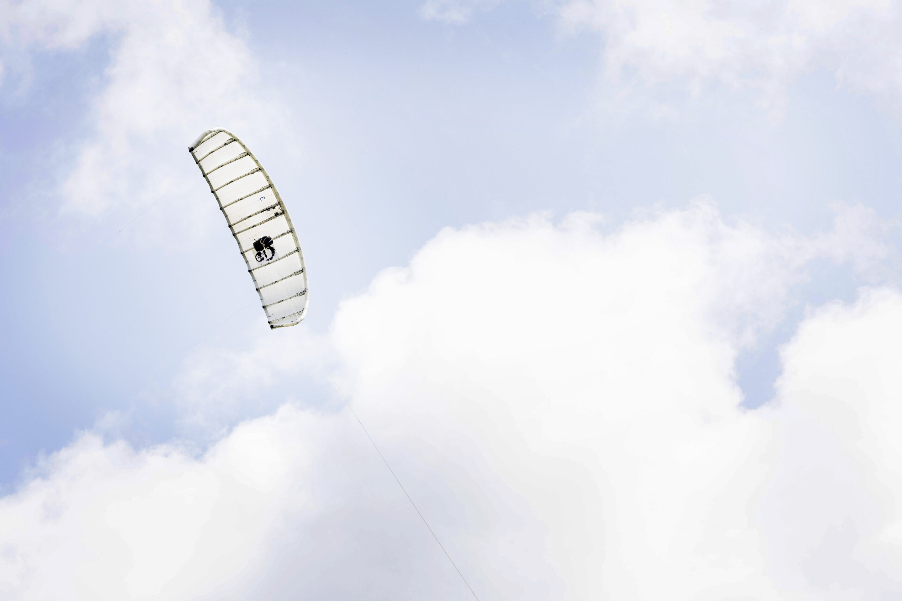

Kitepower's solution replaces diesel generators with Battery Energy Storage Systems (BESS) that can be charged by a highly automated kite. The Hawk kite generates 30kW of energy and stores it directly in a 400 kWh battery. This makes renewable energy truly mobile and accessible to farming, building and island communities. The Hawk is unique as a mobile renewable energy source that can be used completely independently from the grid.

**Step forward**

"The Kitepower Hawk is an important step forward for Kitepower," said CEO Johannes Peschel. "The system is a perfect solution for smaller businesses in agriculture and construction looking for a sustainable way to generate electricity. The system is easy to install, can produce day and night, and it is highly efficient."

The HAWK system was developed based on popular demand from customers and partners who need a relatively small system that can be flown a few times a week to meet energy needs throughout the week. In more and more places, battery energy storage systems are being deployed to support the electrification of vehicle and machinery fleets. However, these batteries are still often combined with diesel generators or are transported off-site to be charged with 'grey' electricity. Hawk charges the battery on site with renewable energy. This allows construction companies to charge their electric vehicles with locally generated renewable energy. Energy generation takes place several times a week, e.g. at times when there is no other activity, such as at night. The kite is then flown at an altitude of about 350 meters.

**Kitepower**

Kitepower is a leading start-up in Airborne Wind Energy (AWE), developing innovative and cost-effective alternatives to existing wind turbines. Kitepower's patented technology is a game-changer in the wind energy sector: Kitepower uses up to 90% less material with the potential to be twice as efficient as conventional wind turbines with the same power output. Unlike conventional wind turbines, Kitepower systems do not require resource-consuming towers or heavy foundations and are therefore highly mobile and easy to install. The system is able to harness stronger and more persistent winds at higher altitudes, providing capacity factors of more than 0.5 and in return cost-effective electricity generation.The company was founded in 2016 by Johannes Peschel and Roland Schmehl as a spin-out from the airborne wind energy group at Delft University of Technology. Kitepower has a team of experienced engineers and technicians working on the development of innovative wind energy systems. The team works with, among others, the Dutch Ministry of Defence, the United Nations World Food Program, and leading energy provider RWE Renewables.

**Note to editors (not for publication)**

Do you have any questions following this press release or are you interested in an interview? If so, please contact Victor-Jan Vanparijs at v.vanparijs@kitepower.nl.

**Over: Kitepower**

**Newsroom**

Bekijk het volledige persbericht inclusief meer foto's en video's in onze Newsroom.

[Bekijk het volledige persbericht](https://kitepower.presscloud.ai/pers/kitepower-introduces-self-charging-battery-system-with-new-hawk)

[Bekijk alle voorgaande persberichten](https://kitepower.presscloud.ai)

**Contact informatie**

Naam: Victor-Jan Vanparijs

E-mail: v.vanparijs@kitepower.nl