**Kitepower announces Claudio Vergara as new Chief Technology Officer**

**Delft, Netherlands, 19 June 2024&ndash; Kitepower, a leading startup in renewable energy, is pleased to announce Claudio Vergara as its new Chief Technology Officer (CTO). Vergara has extensive experience in both hardware and software development, especially in providing clean and reliable electricity to developing countries.**

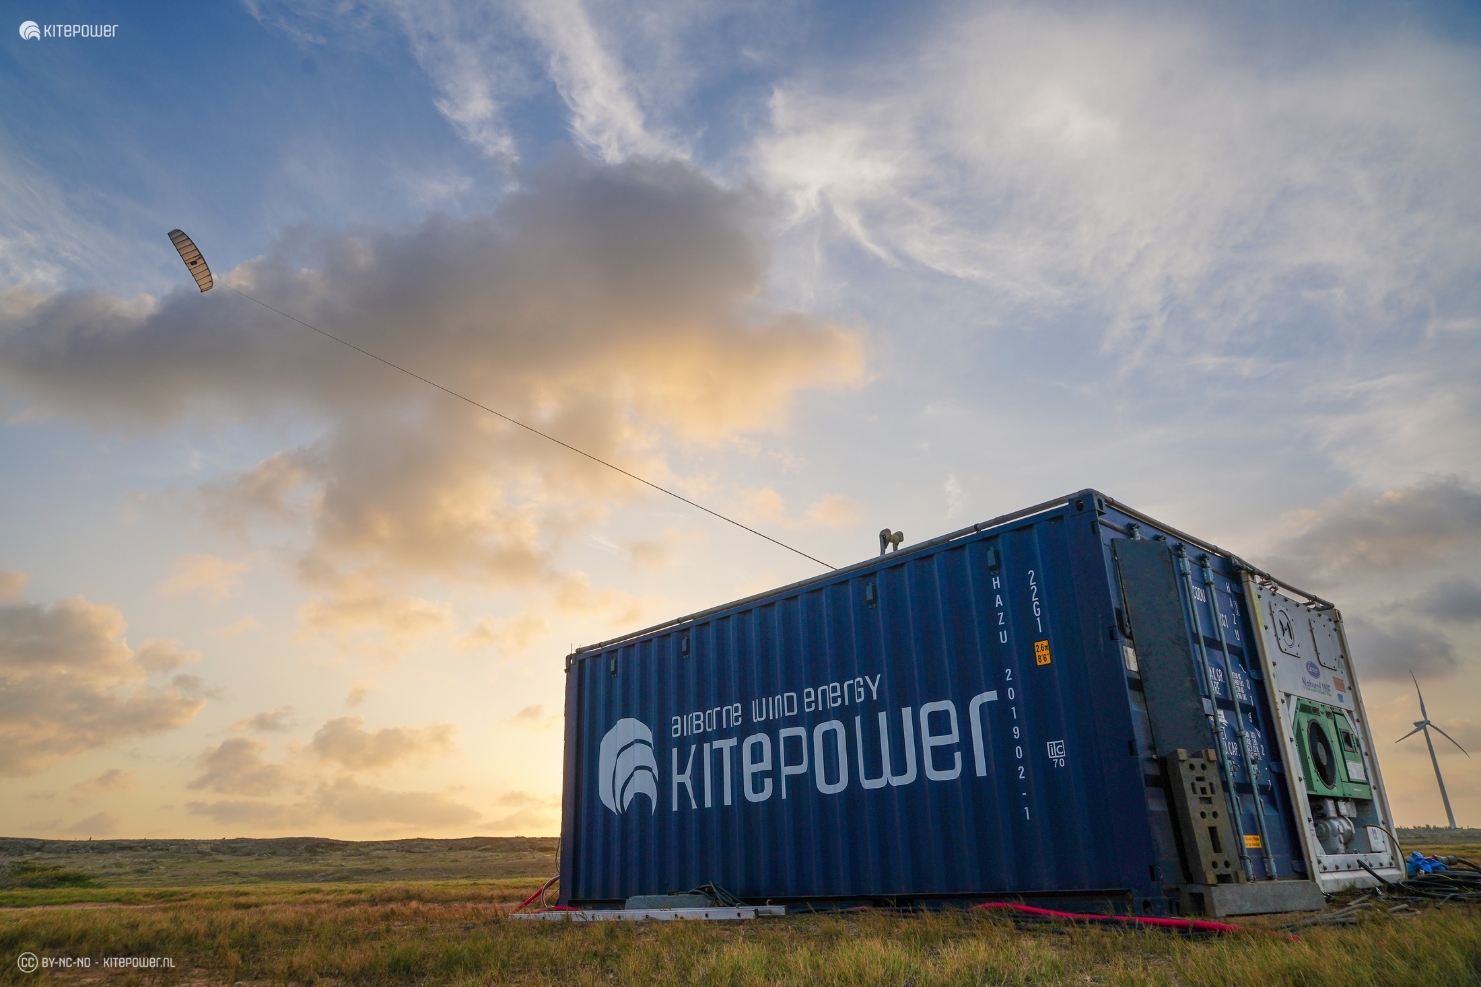

Claudio joins Kitepower from ZOLA Electric, where he played a key role in advancing access to sustainable energy. He has deep knowledge of the electric power sector, focusing on distributed controls and battery energy storage systems. His commitment to clean energy fits perfectly with Kitepower's mission to transform wind energy.

**Extensive experience**

"We are thrilled to welcome Claudio Vergara to the Kitepower team”, said Johannes Peschel, CEO of Kitepower. “His extensive experience in the renewable energy sector and his proven ability to drive innovation to the market make him the ideal candidate to lead our technology development and product release efforts. We are confident that Claudio's expertise and Silicon Valley mindset will be instrumental in accelerating our progress towards a more sustainable future powered by kites."

Claudio Vergara shared his excitement about joining Kitepower: "I am very happy to be joining a company doing bold, high-potential innovation like Kitepower. I have dedicated my career to making low-carbon electricity available to everyone, and I look forward to contributing to Kitepower's next-generation solutions in renewable energy. I'm confident this journey will have a big impact on the future of sustainable energy systems."

Kitepower's airborne wind energy systems use high-altitude winds to generate electricity more efficiently than traditional wind turbines. Claudio Vergara’s addition to the team highlights Kitepower's commitment to advancing renewable energy technology.

**Over: Kitepower**

Kitepower, a leading start-up in Airborne Wind Energy (AWE), develops innovative and cost-effective alternatives to traditional wind turbines. Using up to 90% less material, Kitepower&#039;s patented technology is potentially twice as efficient. Unlike conventional turbines, Kitepower systems require no towers or heavy foundations, making them highly mobile and easy to install. They harness stronger, persistent winds at higher altitudes, achieving capacity factors over 0.5 for cost-effective electricity generation. Founded in 2016 by Johannes Peschel and Roland Schmehl as a spin-out from Delft University of Technology, Kitepower collaborates with the Dutch Ministry of Defence, the UN World Food Program, and RWE Renewables.

**Newsroom**

Bekijk het volledige persbericht inclusief meer foto's en video's in onze Newsroom.

[Bekijk het volledige persbericht](https://kitepower.presscloud.ai/pers/kitepower-announces-claudio-vergara-as-new-chief-technology-officer)

[Bekijk alle voorgaande persberichten](https://kitepower.presscloud.ai)