**Kitepower and eFuelution Partner to Drive Green Hydrogen Development**

**Delft, 23-04-2024&ndash; Kitepower and eFuelution, an end-to-end project developer specializing in hydrogen electrolysis projects, are pleased to announce a strategic collaboration. This partnership aims to accelerate the development of green hydrogen projects, leveraging Kitepower's innovative technology as a complementary solution.**

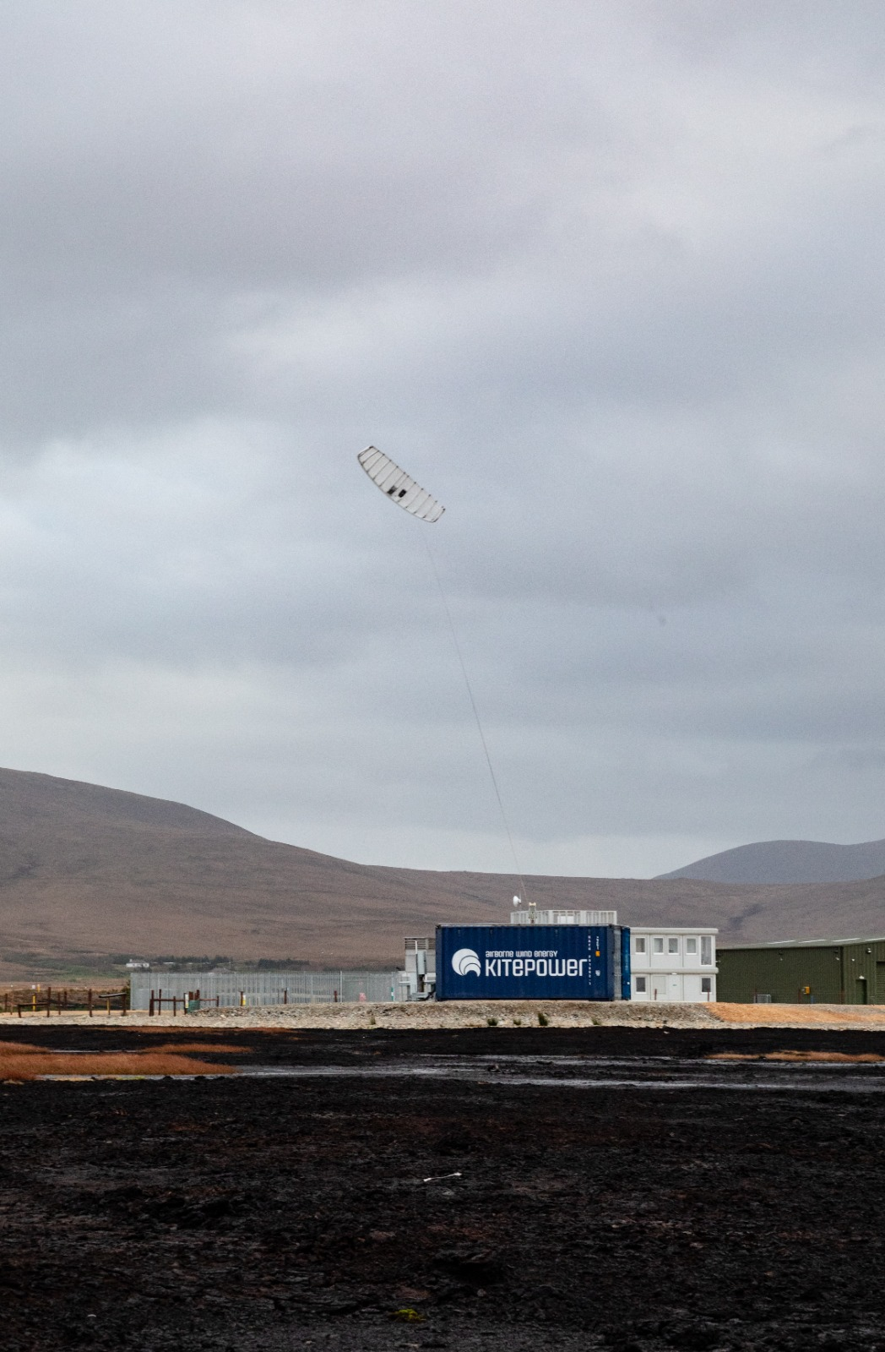

Green hydrogen stands at the forefront of the energy transition as a clean and versatile fuel, applicable across various sectors including transportation, industry, and infrastructure. With the Netherlands aiming for carbon neutrality by 2050, green hydrogen emerges as a pivotal element in achieving this ambitious goal. eFuelution, as a leading project developer dedicated to green hydrogen initiatives, is committed to accelerating and optimizing hydrogen project development, ensuring a sustainable and cost-effective energy solution.

**Synergizing innovation for sustainable solutions**

The collaboration between Kitepower and eFuelution brings together cutting-edge technologies and expertise from both the airborne wind energy and hydrogen sectors. By uniting efforts, the partners seek to expedite the realization of green hydrogen projects while simultaneously driving down production costs.

Johannes Peschel, CEO of Kitepower:

*"We are excited to cooperate with eFuelution, exploring new applications of our system in the hydrogen sector. This partnership empowers us to seamlessly integrate our technology into hydrogen projects, making significant strides in the energy transition."*

Hanno Hardenbol, Project Development Consultant - Clean Energy at eFuelution:

*"Our partnership with Kitepower allows us to leverage their groundbreaking technology with the potential to revolutionize green hydrogen production. Together, we are poised to deliver sustainable and economically viable hydrogen projects."*

**About Kitepower**

Kitepower is a leading start-up in Airborne Wind Energy (AWE), developing innovative and cost-effective alternatives to existing wind turbines. Kitepower's patented technology is a game-changer in the wind energy sector: Kitepower uses up to 90% less material with the potential to be twice as efficient as conventional wind turbines with the same power output. Unlike conventional wind turbines, Kitepower systems do not require resource-consuming towers or heavy foundations and are therefore highly mobile and easy to install. The system is able to harness stronger and more persistent winds at higher altitudes, providing capacity factors of more than 0.5 and in return cost-effective electricity generation.The company was founded in 2016 by Johannes Peschel and Roland Schmehl as a spin-out from the airborne wind energy group at Delft University of Technology. Kitepower has a team of experienced engineers and technicians working on the development of innovative wind energy systems. The team works with, among others, the Dutch Ministry of Defence, the United Nations World Food Program, and leading energy provider RWE Renewables.

**About eFuelution**

Hydrogen is the future for the green industry and mobility, and eFuelution is committed to realizing the crucial hydrogen projects. Combating climate change is eFuelution’s main goal. We develop innovative solutions for generating and transporting hydrogen, which will accelerate the energy transition and contribute to a greener future.

Concretely, eFuelution develops cost-effective hydrogen energy projects that bring world-class innovation to life.

**Over: Kitepower**

**Newsroom**

Bekijk het volledige persbericht inclusief meer foto's en video's in onze Newsroom.

[Bekijk het volledige persbericht](https://kitepower.presscloud.ai/pers/kitepower-and-efuelution-partner-to-drive-green-hydrogen-development)

[Bekijk alle voorgaande persberichten](https://kitepower.presscloud.ai)

**Contact informatie**

Naam: Kitepower

E-mail: v.vanparijs@kitepower.nl