**Kitepower and Beyond the Sea strengthen and expand partnership**

**Delft, Netherlands/Bordeaux, France, 10 September 2024&ndash; Kitepower, a pioneering Dutch company in airborne wind energy, and Beyond the Sea, a French startup specializing in marine propulsion systems, are pleased to announce the renewal and expansion of their groundbreaking partnership. Following the success of their initial collaboration in 2023, the two companies are launching a new, ambitious project aimed at revolutionizing kite design, simulation, characterization, and control.**

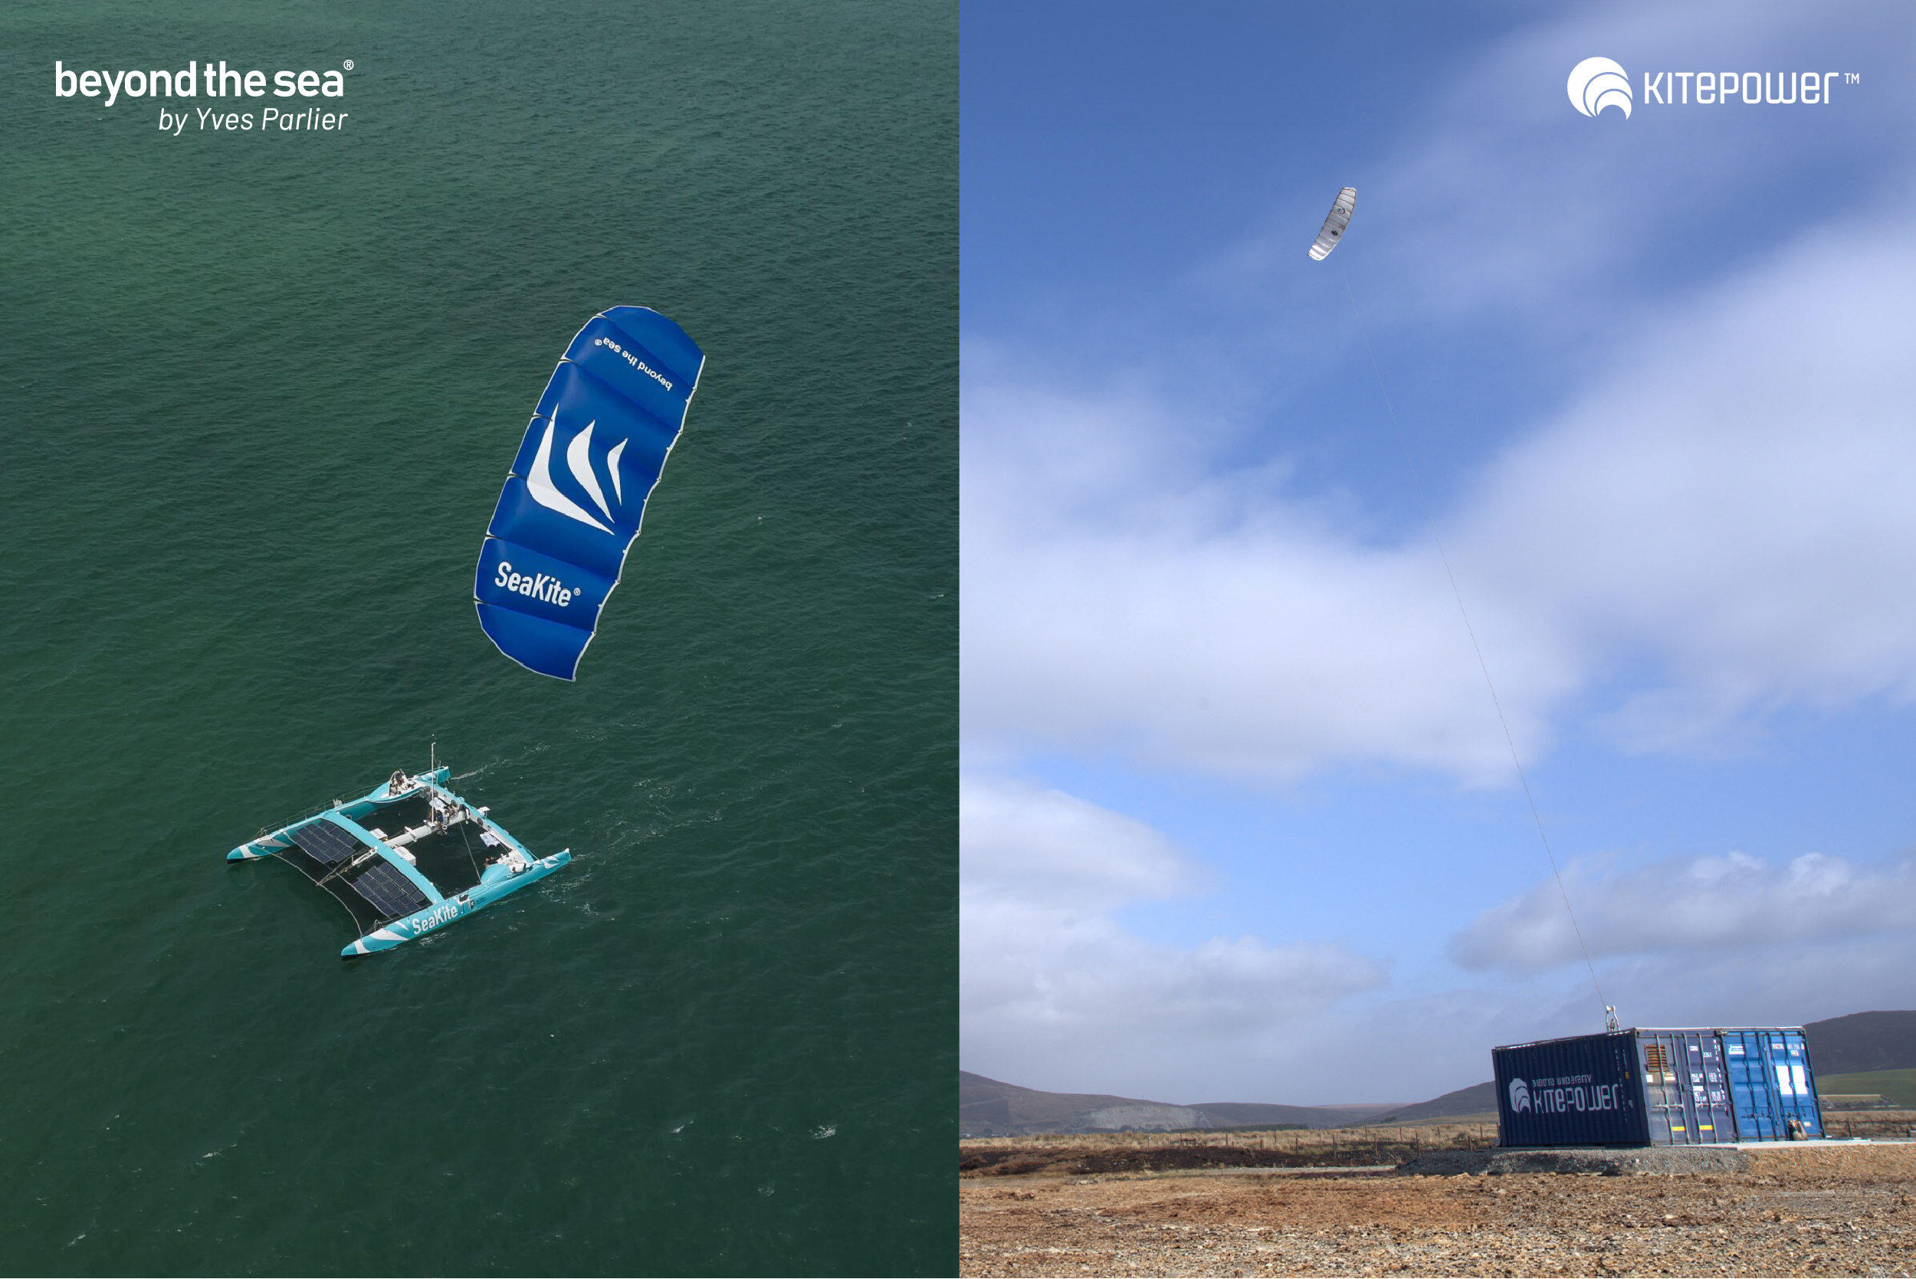

**A strengthened alliance for innovation**

This renewed partnership, extending through June 2027, will operate across both the Netherlands and France, with a key focus on advancing modeling, simulation, and the development of a unified simulation platform. By combining their expertise and innovative approaches, Kitepower and Beyond the Sea aim to deliver cutting-edge kite designs that significantly enhance the efficiency and sustainability of energy generation and marine propulsion systems.

**Key areas of collaboration**

The collaboration will target three strategic areas: advanced kite design and development, academic research, and system modeling & mechatronics. This joint effort is expected to significantly elevate the technological capabilities of both companies, positioning them as leaders in the field. The partnership will facilitate the exchange of detailed plans and construction methodologies for kites and their bridles. Jointly developed simulation algorithms will refine kite design processes, and innovative methods, sensors, and algorithms will validate and enhance kite performance. Continuous sharing of experimental data will drive this iterative process.

**Leadership Perspectives**

Johannes Peschel, CEO of Kitepower, underscored the importance of this collaboration: “Renewing and expanding our partnership with Beyond the Sea is a major milestone in our mission to transform airborne wind energy. Our initial collaboration was highly successful, and we are excited to deepen our cooperation by aligning our software and simulation platforms, coordinating research activities, and synchronizing the work of our PhD students with Beyond the Sea’s research team.”

Yves Parlier, CEO of Beyond the Sea, highlighted the synergy between the two companies: “This partnership showcases the powerful collaboration between our teams. By leveraging our combined strengths, we are setting new standards for innovation and sustainability in kite technology. Together, we are poised to deliver groundbreaking advancements that will redefine the future of kite applications.”

**About Kitepower**

Kitepower is a leading start-up in Airborne Wind Energy (AWE), developing innovative and cost-effective alternatives to existing wind turbines. Kitepower's patented technology is a game-changer in the wind energy sector: Kitepower uses up to 90% less material with the potential to be twice as efficient as conventional wind turbines with the same power output.

Unlike conventional wind turbines, Kitepower systems do not require resource-consuming towers or heavy foundations and are therefore highly mobile and easy to install. The system is able to harness stronger and more persistent winds at higher altitudes, providing capacity factors of more than 0.5 and in return cost-effective electricity generation.The company was founded in 2016 by Johannes Peschel and Roland Schmehl as a spin-out from the airborne wind energy group at Delft University of Technology. Kitepower has a team of experienced engineers and technicians working on the development of innovative wind energy systems. The team works with, among others, the Dutch Ministry of Defence, the United Nations World Food Program, and leading energy provider RWE Renewables.

**About Beyond the Sea**

Beyond the Sea, created by Yves Parlier, develops and commercializes kite traction systems able to deliver part or all of the energy needed to propel a ship depending on the navigation area, the performance and the characteristics of the boat. The company aims to answer the problem of energy dependence of shipowners with a goal to decarbonize maritime transport. The company has developed SeaKite, a fully automated kite traction system, to reduce the emissions of the equipped vessel. Connected to the boat by its lines, SeaKite pilots itself automatically and can fly statically or dynamically depending on the desired traction force. The kite can be used alone or in addition to another mode of propulsion. Currently available in several different sizes, the system adapts to all types of boats.

**Over: Kitepower**

Kitepower, a leading start-up in Airborne Wind Energy (AWE), develops innovative and cost-effective alternatives to traditional wind turbines. Using up to 90% less material, Kitepower&#039;s patented technology is potentially twice as efficient. Unlike conventional turbines, Kitepower systems require no towers or heavy foundations, making them highly mobile and easy to install. They harness stronger, persistent winds at higher altitudes, achieving capacity factors over 0.5 for cost-effective electricity generation. Founded in 2016 by Johannes Peschel and Roland Schmehl as a spin-out from Delft University of Technology, Kitepower collaborates with the Dutch Ministry of Defence, the UN World Food Program, and RWE Renewables.

**Newsroom**

Bekijk het volledige persbericht inclusief meer foto's en video's in onze Newsroom.

[Bekijk het volledige persbericht](https://kitepower.presscloud.ai/pers/kitepower-and-beyond-the-sea-strengthen-and-expand-partnership)

[Bekijk alle voorgaande persberichten](https://kitepower.presscloud.ai)