**Airborne Wind Energy integrated into German Renewable Energy Act**

**Delft, May 1, 2024- Kitepower is proud to announce a monumental achievement in the renewable energy sector. The German Renewable Energy Act (EEG) is set to include provisions specifically recognizing and supporting Airborne Wind Energy (AWE), a significant milestone for the industry.**

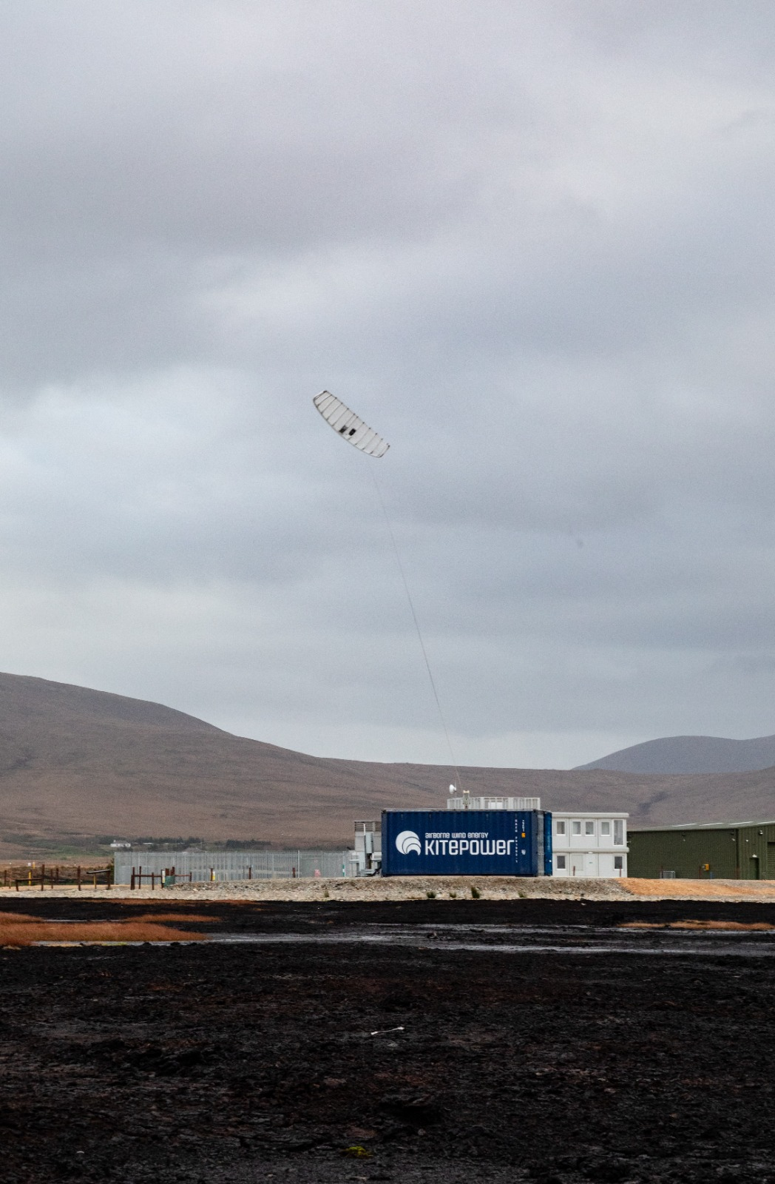

Kitepower, a pioneering member of Airborne Wind Europe, has been instrumental in advocating for the integration of AWE into national energy policies, with a proven track record of innovative systems poised to reshape the renewable energy landscape. Today, the company celebrates a significant milestone as Germany, a key player in Europe's renewable energy transition, embraces AWE as a fundamental component of its energy strategy.

**Solarpakket**

Recent developments in the German parliament saw the approval of the "Solarpaket," which includes provisions for AWE-specific tariffs within the EEG. This historic decision marks the first time such measures have been implemented, signaling a major recognition of AWE's potential contribution to the renewable energy mix.

Speaking on the significance of this milestone, Johannes Peschel, Kitepower's CEO remarked, "This is a historic moment for the AWE industry and for sustainable energy as a whole. Germany's decision to include AWE in its renewable energy framework not only validates our technology but also paves the way for accelerated adoption across Germany, Europe and beyond."

**Benefits**

The incorporation of AWE-specific tariffs within the EEG is poised to unlock a range of benefits for the industry. These include enhanced access to financing, heightened international visibility, improved research and development conditions, regulatory adaptations, and the strengthening of European industrial leadership in renewable energy innovation.

As Kitepower continues to push the boundaries of renewable energy technology, the company remains committed to driving positive change and shaping a sustainable future for generations to come. With AWE gaining recognition and support on the global stage, the potential for clean, reliable, and scalable energy solutions has never been brighter.

**About Kitepower**

Kitepower is a leading start-up in Airborne Wind Energy (AWE), developing innovative and cost-effective alternatives to existing wind turbines. Kitepower's patented technology is a game-changer in the wind energy sector: Kitepower uses up to 90% less material with the potential to be twice as efficient as conventional wind turbines with the same power output. Unlike conventional wind turbines, Kitepower systems do not require resource-consuming towers or heavy foundations and are therefore highly mobile and easy to install. The system is able to harness stronger and more persistent winds at higher altitudes, providing capacity factors of more than 0.5 and in return cost-effective electricity generation.

The company was founded in 2016 by Johannes Peschel and Roland Schmehl as a spin-out from the airborne wind energy group at Delft University of Technology. Kitepower has a team of experienced engineers and technicians working on the development of innovative wind energy systems. The team works with, among others, the Dutch Ministry of Defence, the United Nations World Food Program, and leading energy provider RWE Renewables.

**Over: Kitepower**

**Newsroom**

Bekijk het volledige persbericht inclusief meer foto's en video's in onze Newsroom.

[Bekijk het volledige persbericht](https://kitepower.presscloud.ai/pers/airborne-wind-energy-integrated-into-german-renewable-energy-act)

[Bekijk alle voorgaande persberichten](https://kitepower.presscloud.ai)